Concepts of Hypothesis Testing – II
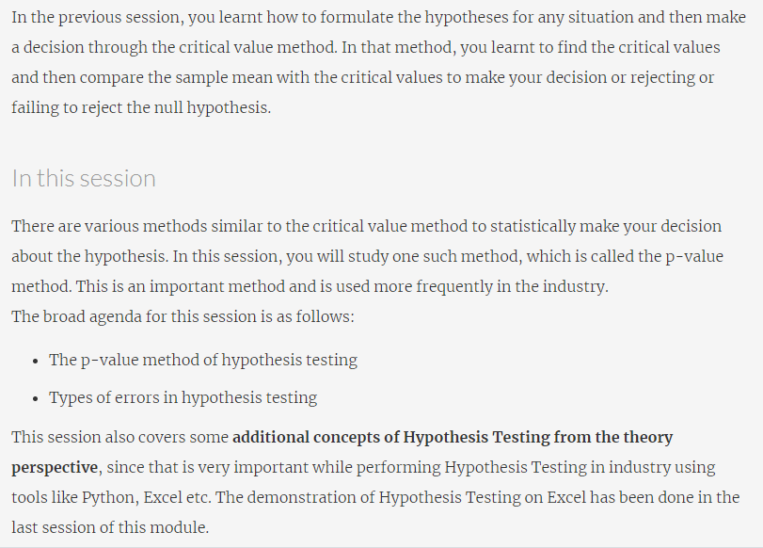

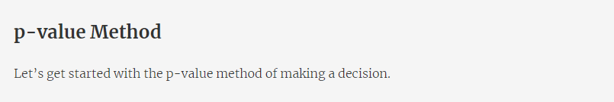
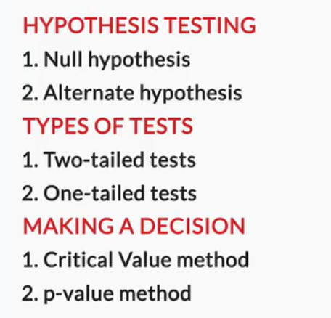
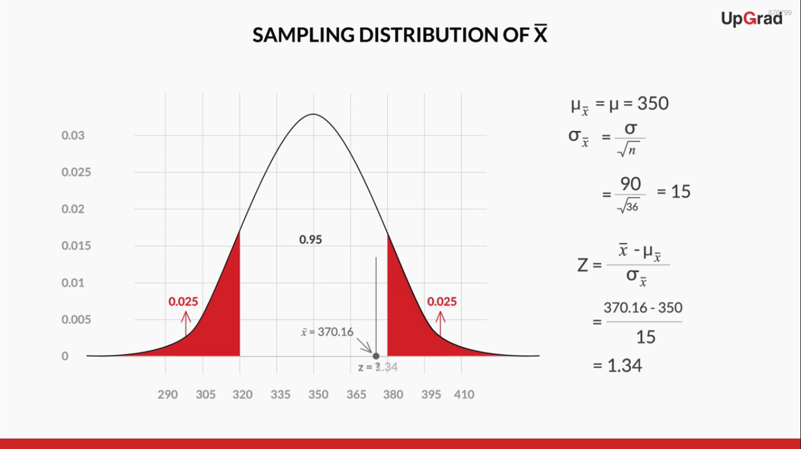
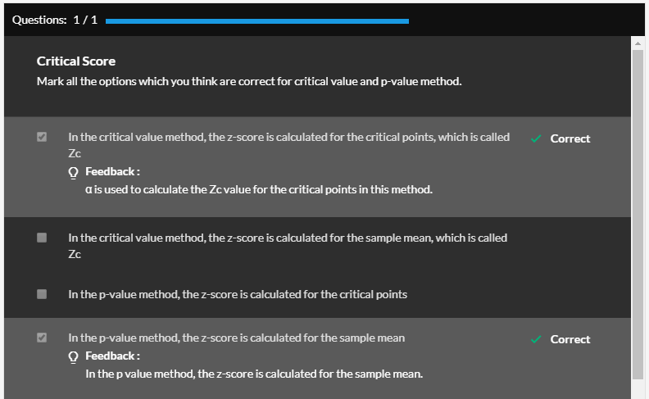
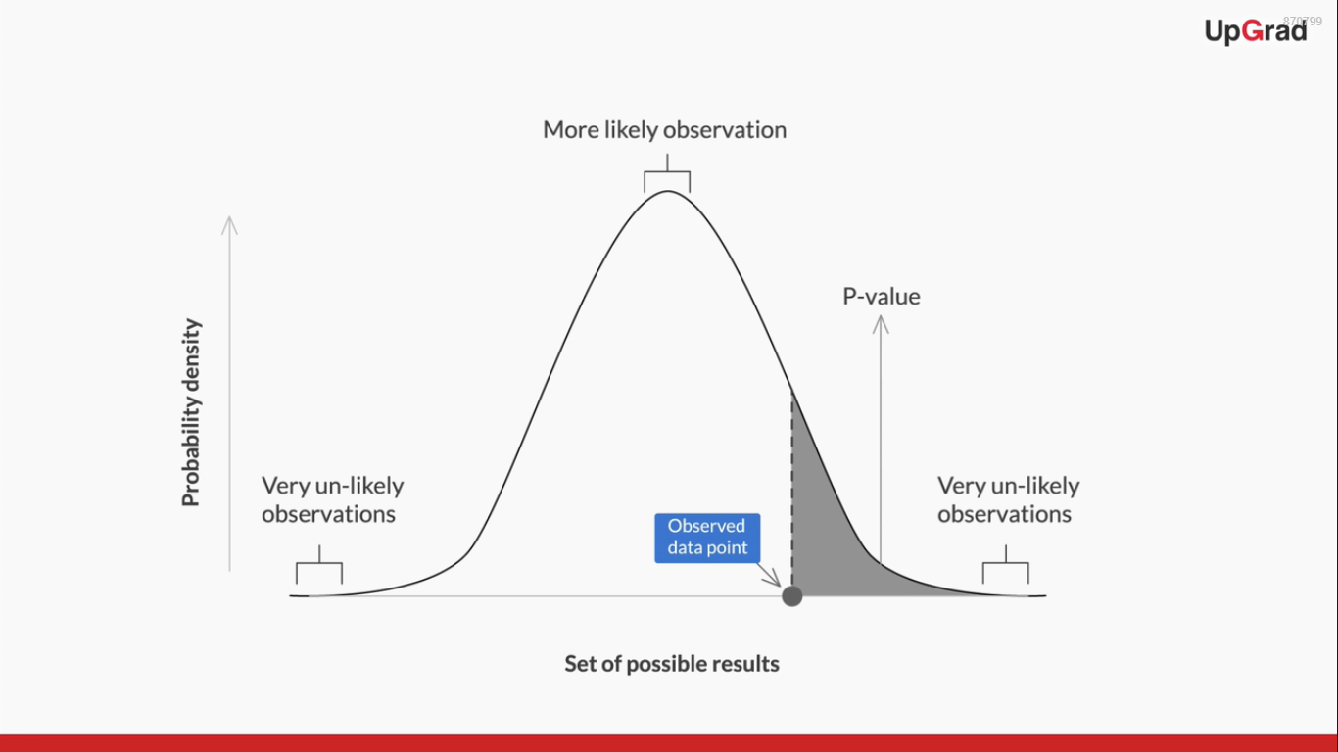


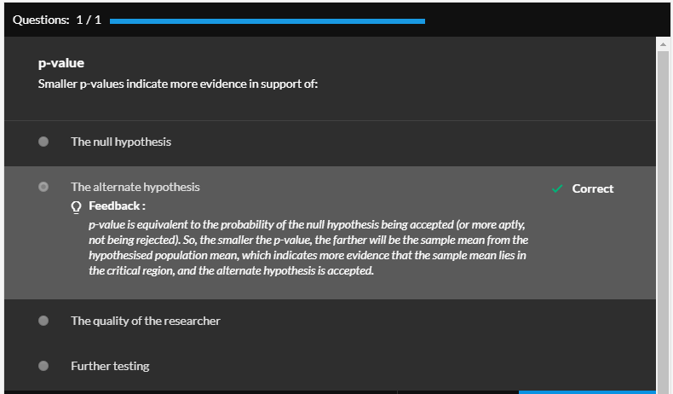
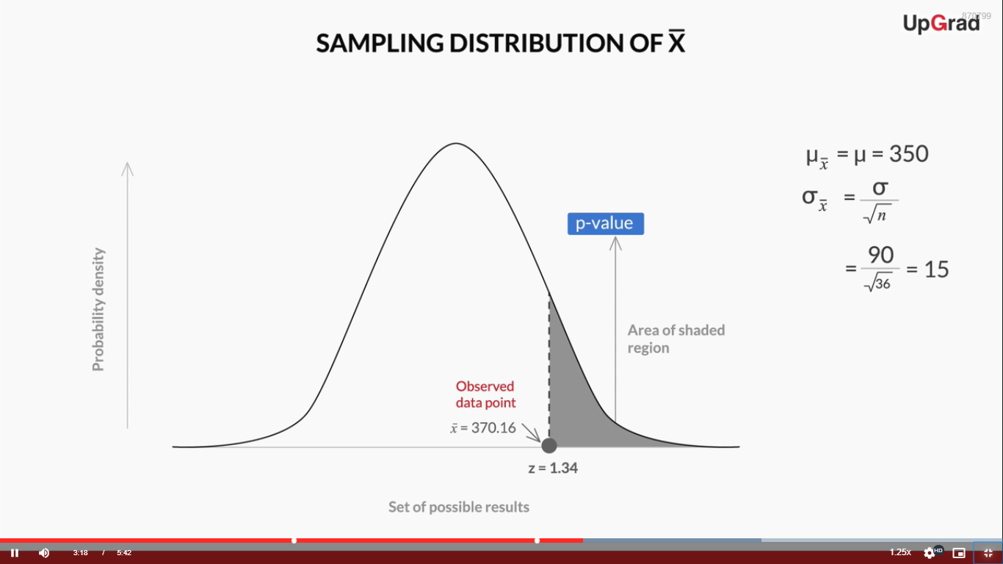
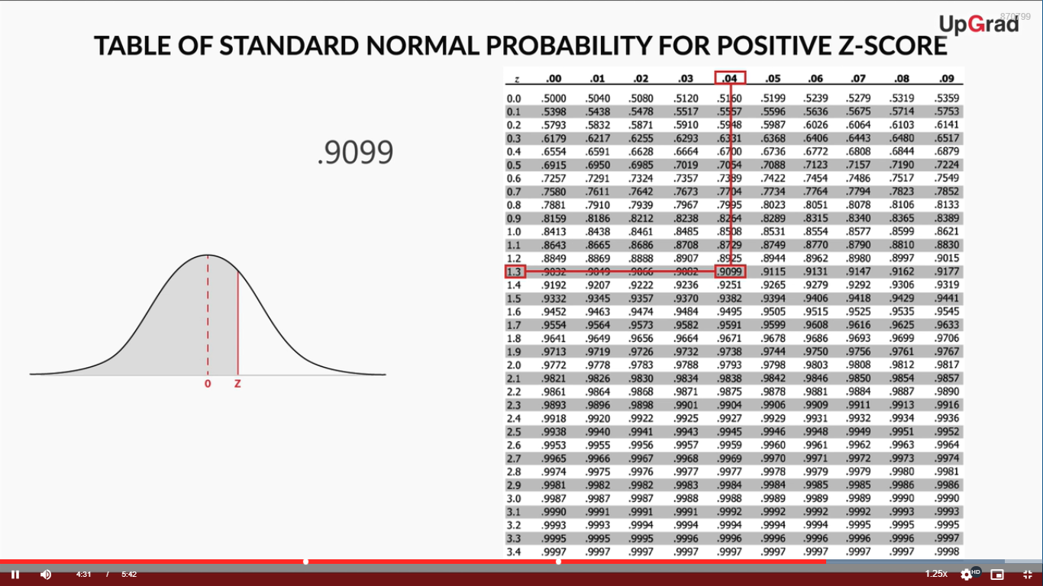
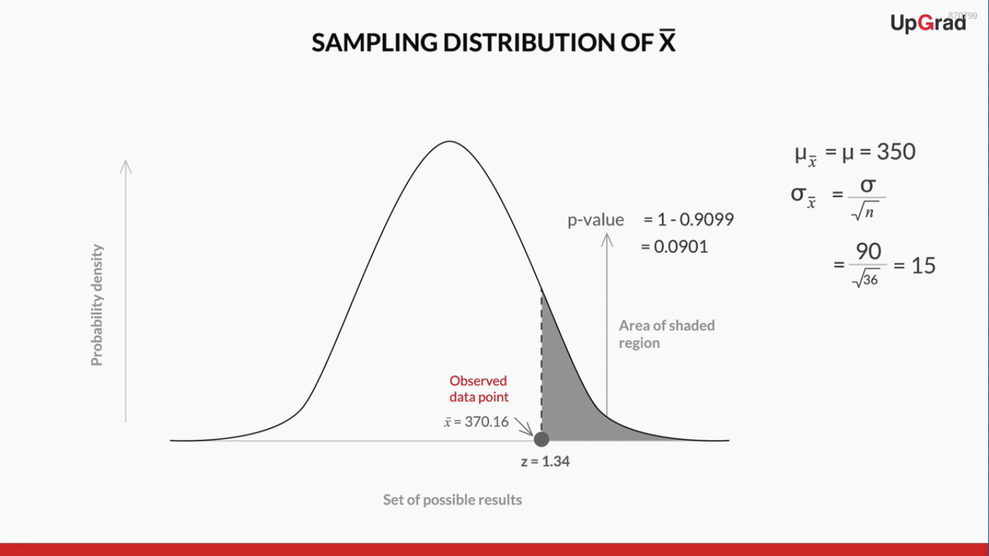
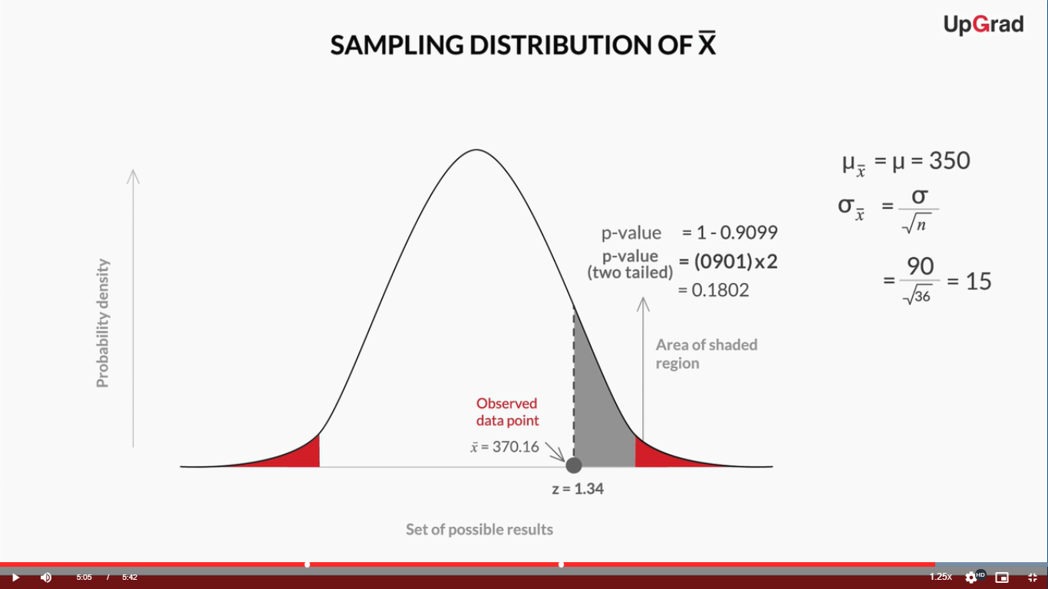
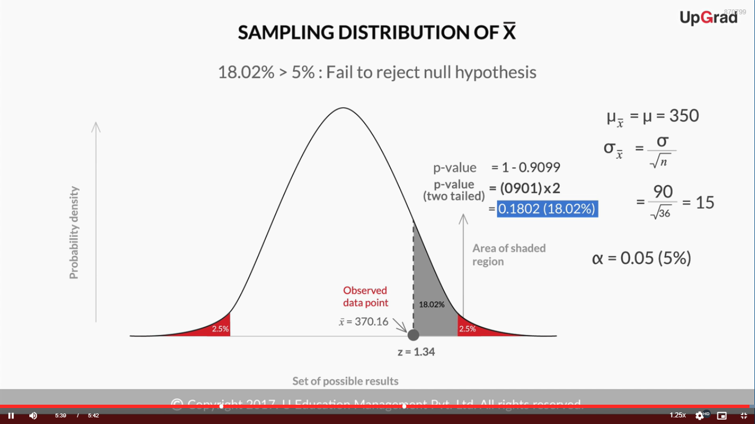
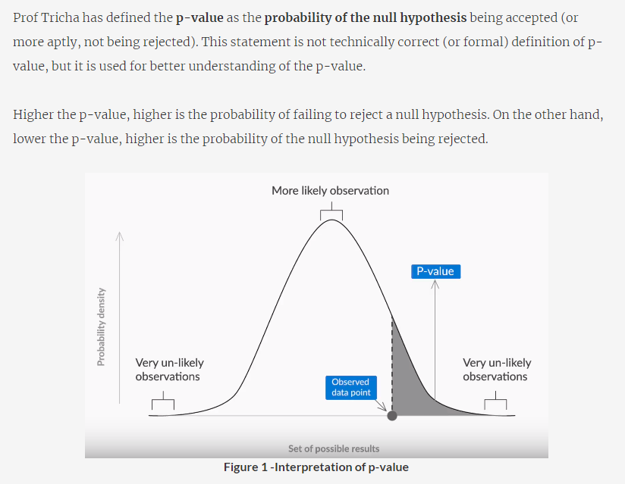
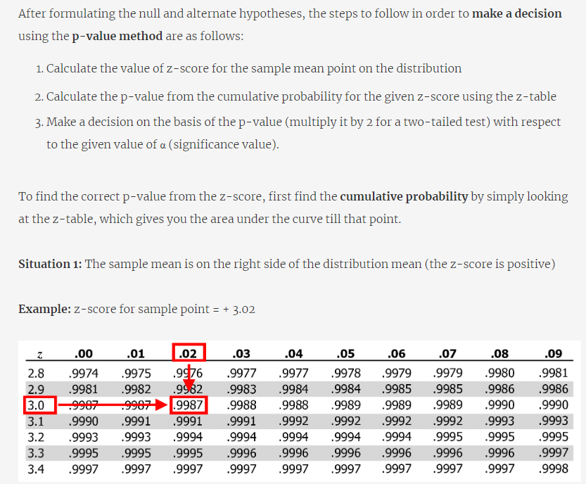
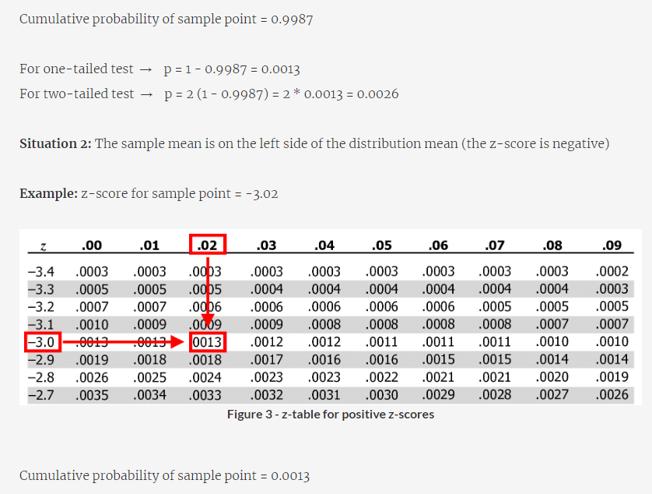
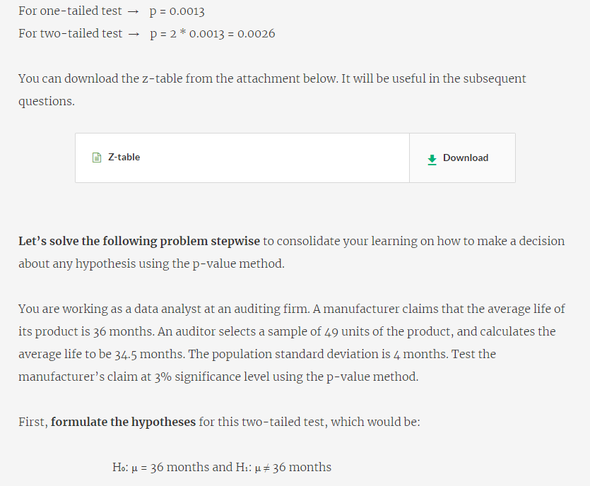
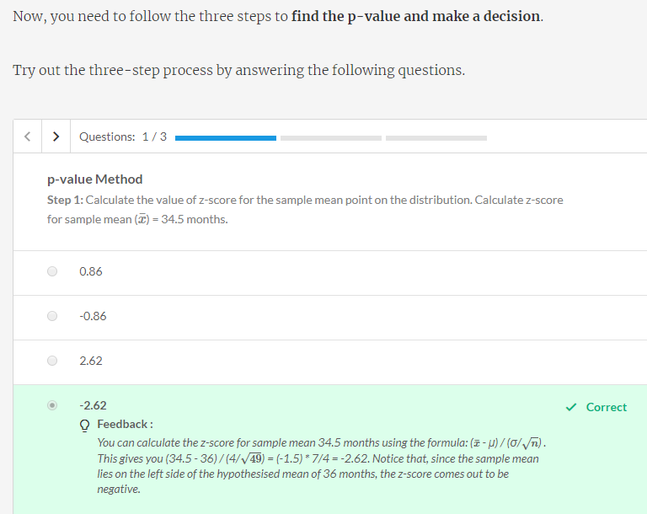
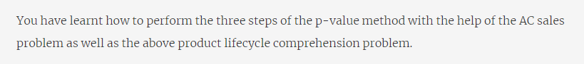
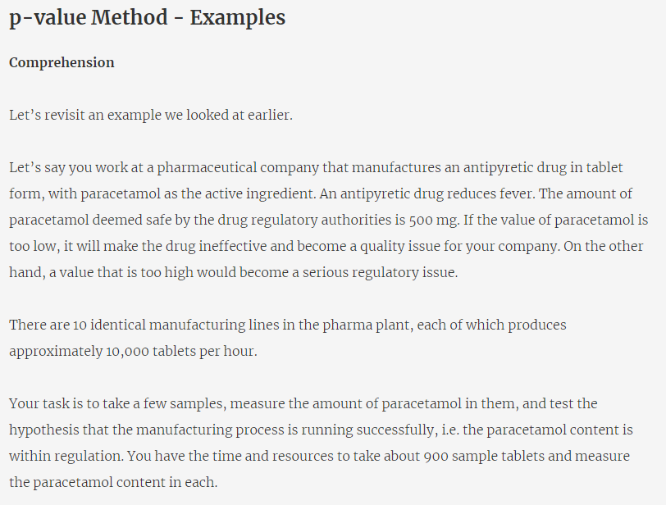
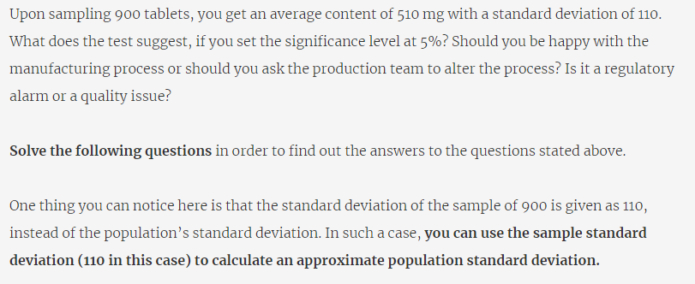
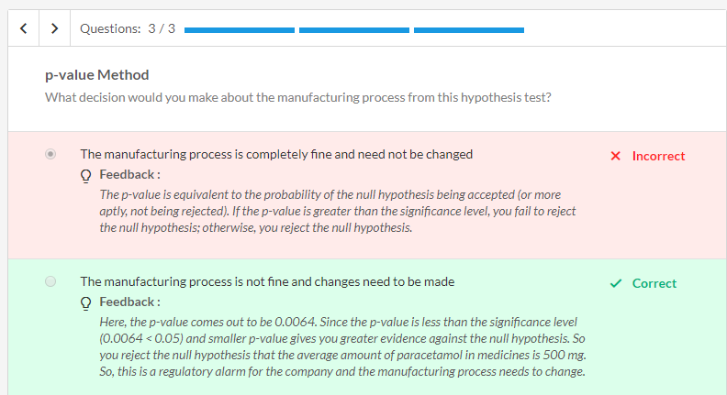
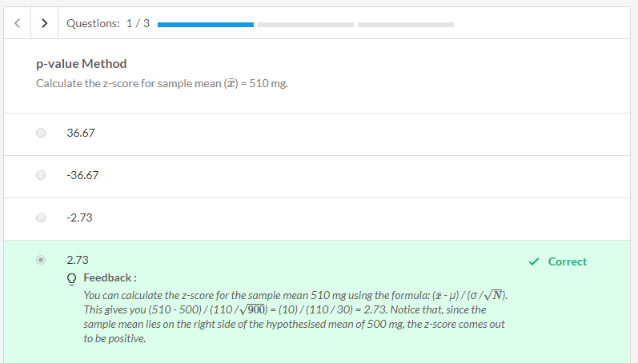
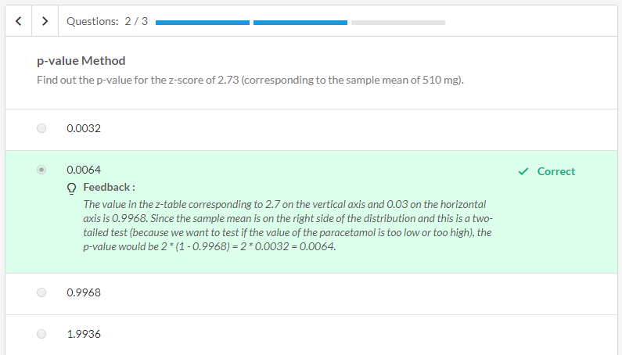
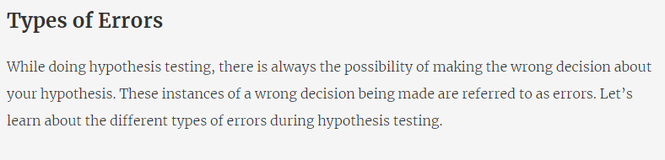
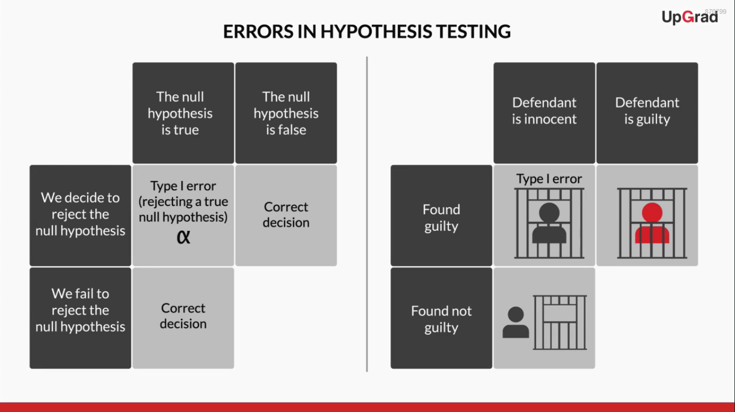
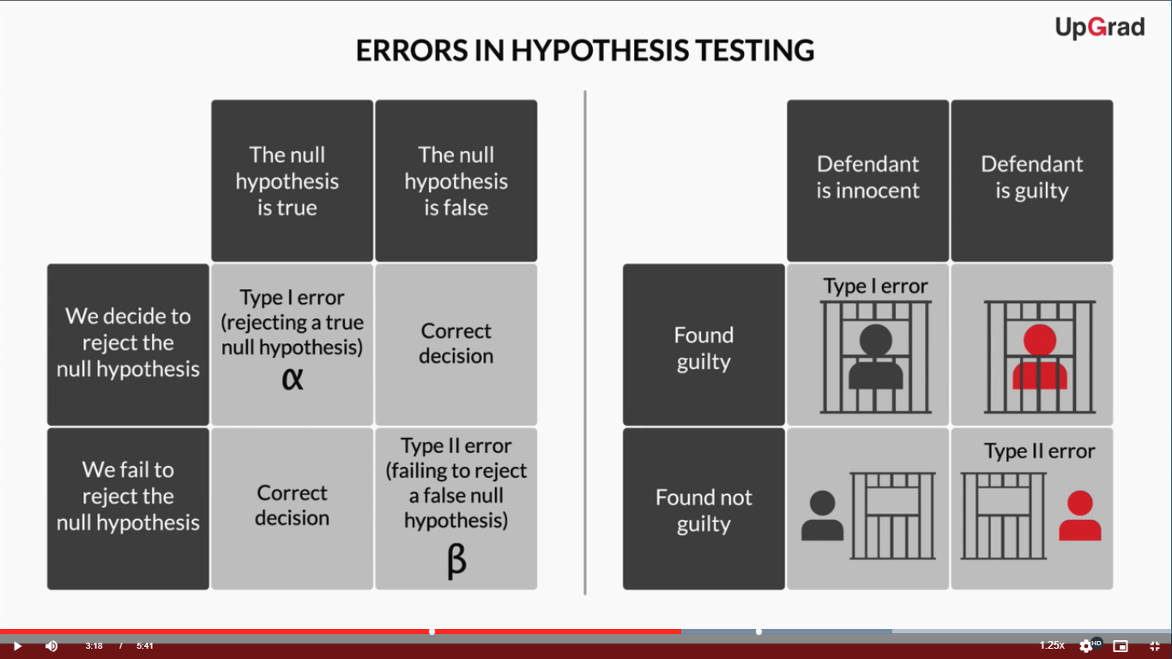
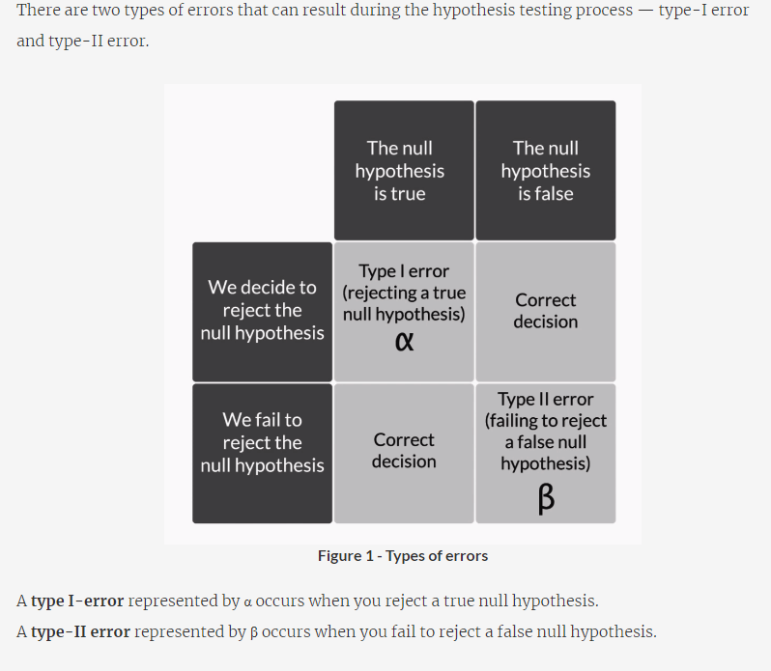
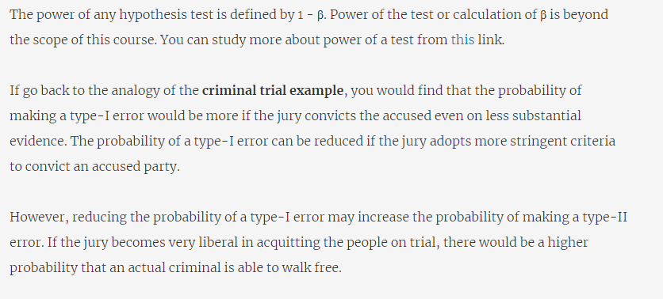
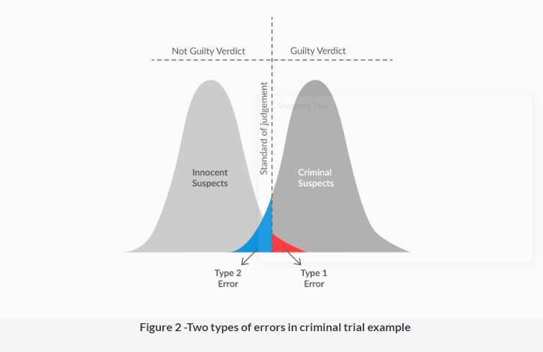
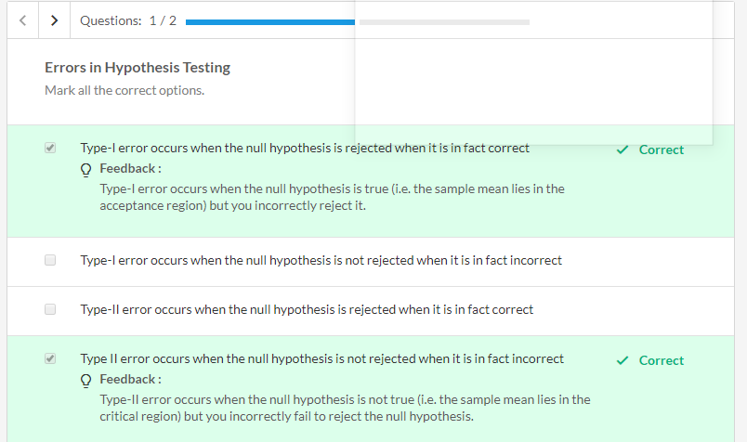
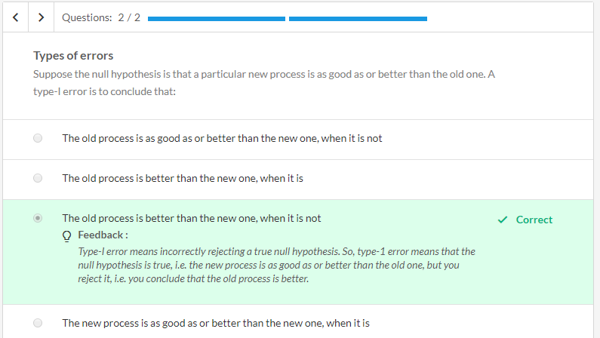
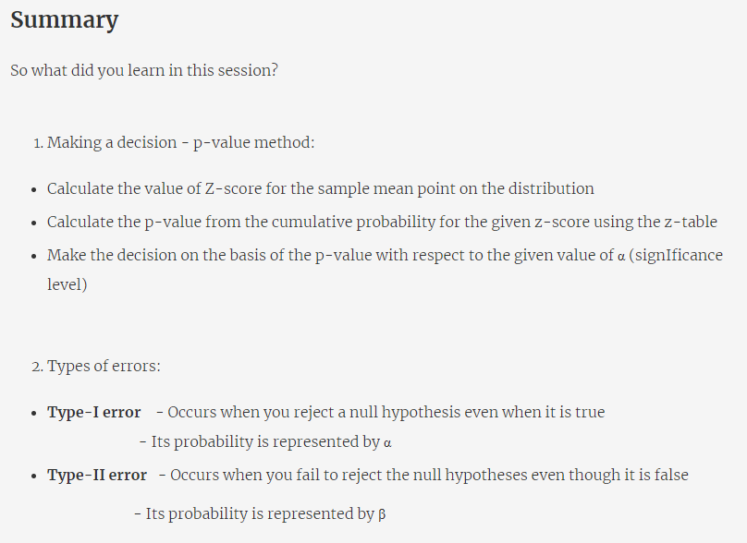
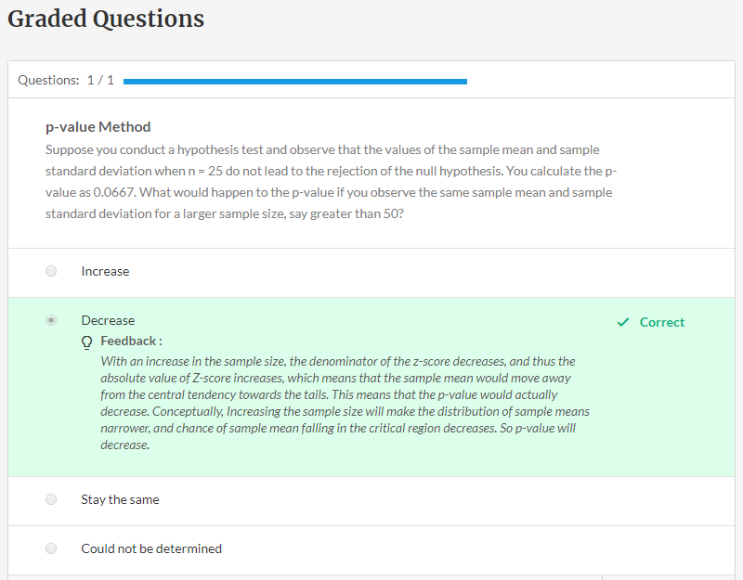
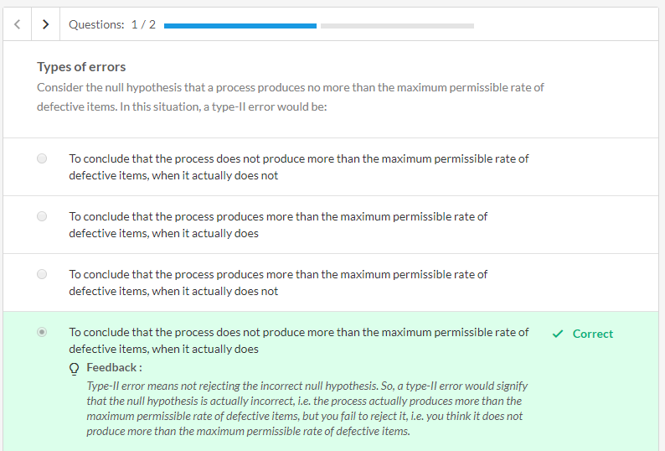
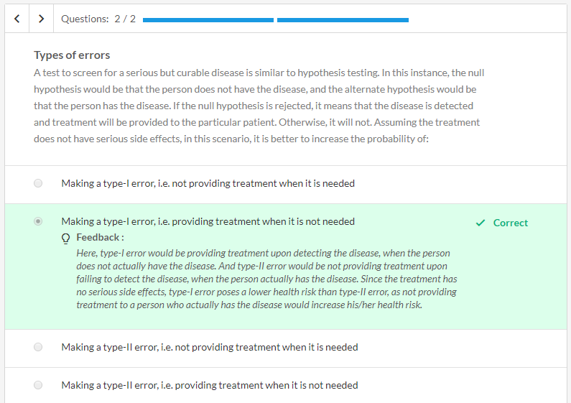

Valid email ID
Description
Consider that email IDs are supposed to be for the following format:
username@website.extension.
Here, there are three conditions to keep in mind:
1. The username can only contain characters 0-9, a-z and A-Z.
2. The website name can contain only characters a-z
3. The extension can have 2 or 3 alphabets(a-z).
Given an email ID, you have to determine if it is valid or not.
Sample Input:
prerna@upgrad.com
Sample Output:
valid
import re
def checkmail(email):
if(re.match("^[a-zA-Z0-9]+@[a-z]+\.[a-z]{2,3}$", email) != None):
return "valid"
return "invalid"

email=input()
print(checkmail(email))

def checkmail(mail):
x=mail.split("@")
y=x[1].split(".")
a=[]
flag = 0
for i in range(len(x[0])):
a.append(x[0][i])
if mail.count(".")>1 or mail.count("@")>1:
flag = 1
else:
#extension
if len(y[1])==2 or len(y[1])==3 and y[1].islower():
#website
if y[0].islower() and y[0].isalpha():
#username
for i in range(len(a)):
if a[i].islower() or a[i].isupper() or a[i].isdigit():
pass
else:
flag = 1
else:
flag = 1
else:
flag = 1
if flag == 0:
return('valid')
else:
return('invalid')

email=input()
print(checkmail(email))

Flatten a list
Description
Given a nested list, write python code to flatten the list.
Note: The input list will strictly have 2 levels, i.e. the list will be of the form [[1,2],[3,4]]. Inputs like [1,[2,3]] and [[1,[2,3],4],5] are not applicable.
For example: If the input list is :
[[1,2,3],[4,5],[6,7,8,9]]
Then the output should be:
[1,2,3,4,5,6,7,8,9]

import ast,sys
input_str = sys.stdin.read()
input_list = ast.literal_eval(input_str)
flat_list = [item for sublist in input_list for item in sublist]

print(flat_list)

import ast,sys
input_str = sys.stdin.read()
input_list = ast.literal_eval(input_str)
flat_list = []
for sublist in input_list:
for item in sublist:
flat_list.append(item)
print(flat_list)

Squares
Description
Given a list of positive integers, you have to find numbers divisible by 3 and replace them with their squares.
For example, consider the list below:
Input: [1,2,3,4,5,6]
The output for the above list would be: [1,2,9,4,5,36]. Because 3 and 6 were divisible by 3, these numbers were replaced with their squares.

import ast,sys
input_str = sys.stdin.read()
input_list = ast.literal_eval(input_str)
flat_list = [item**2 if item%3==0 else item for item in input_list]

print(flat_list)

import ast,sys
input_str = sys.stdin.read()
input_list = ast.literal_eval(input_str)
output = [x if x%3!=0 else x**2 for x in input_list]
print(output)

A weird sum
Description
Write a program that computes the value of n+nn+nnn+nnnn with a given digit as the value of n.
For example, if n=9 , then you have to find the value of 9+99+999+9999.

n=input()
sum = 0
for i in range(4):
sum += int(n*(i+1))
print(sum)

n=input()
n1 = int( "%s" % n)
n2 = int( "%s%s" % (n,n) )
n3 = int( "%s%s%s" % (n,n,n) )
n4 = int( "%s%s%s%s" % (n,n,n,n) )

print (n1+n2+n3+n4)

Frequent Letters
Description
Given a string, you have to find the first n most frequent characters in it.
You have to print these n letters in alphabetically sorted order.
The input will contain two lines, the first line will contain a string and the second line will contain the letter n.
The output should be a list of n most frequent letters in alphabetically sorted order.
Note: If there are two letters with the same frequency, then the alphabetically preceding alphabet should be picked first. (For example, in "aabbccc", if n=2, then output list would have c and a.)
Sample Input:
ddddaacccb
3

Sample Output:
['a', 'c', 'd']

In the above example, the order of frequencies is : d>c>a>b
Here, d,c and a are three most frequent characters which are displayed in alphabetically sorted order.

string=input()
n=int(input())
#write your code here
char_dict ={}
freqchh = []
max = 0
for ch in string:
char_dict[ch] = char_dict.get(ch,0) +1
#print(d)
for ch in char_dict:
if char_dict.get(ch,0) > 1:
if(len(freqchh) < n):
freqchh.append(ch)
freqchh.sort()
print(freqchh)

string=input()
n=int(input())
import collections
out=[collections.Counter(string).most_common(i+1)[i][0] for i in range(n)]
out.sort()
print(out)

2D array
Description
Write Python code which takes 2 numbers x and y as input and generates a 2-dimensional numpy array where value in the i-th row and j-th column of the array should be (i+j)/2.
Note: i=0,1,...x-1 and j=0,1....,y-1
The input will have two lines with x and y respectively.
The output should be a 2D numpy array.
Sample Input:
3
4
Sample Output:
[[0. 0.5 1. 1.5]
[0.5 1. 1.5 2. ]
[1. 1.5 2. 2.5]]

import numpy as np
x=int(input())
y=int(input())
final_list = []
for i in range(x):
row_list = []
for j in range(y):
row_list.append((i+j)/2)
final_list.append(row_list)
arr = np.array(final_list)
print(arr)

x=int(input())
y=int(input())
from numpy import zeros
a = zeros([x,y])
for row in range(x):
for col in range(y):
a[row][col]= (row+col)/2
print(a)



Even marks
Description
Consider a table consisting the marks of students in a mathematics test along with their unique student_id. Write a query to determine which students got the marks that is divisible by 10 and which students did not. Make sure that the output is ordered by student_id.﻿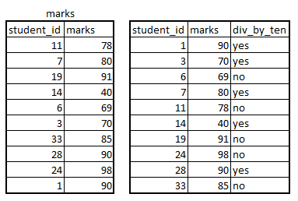

use upgrad;
select *,
(
CASE
WHEN MOD(marks, 10) = 0 THEN 'yes'
ELSE 'no'
END) AS div_by_ten
from marks order by student_id;

use upgrad;

select *,
case
when mod(marks,10) = 0 then 'yes'
else 'no'
end as 'div_by_ten'
from marks
order by student_id;

Average distance
Description
Consider a table employee storing the details of the employee.
ssn : social security number of the employee
address : storing the address of the employee
Looking at the address field in the employee table, you would notice that all the employees reside in "Fondren, Houston, TX". Consider the integer in the address field as house number. Consider the distance between the two houses as the difference in the house numbers, so the distance between house number 2 and 38 is 36 units. Write a query to determine the average distance between the house of the employee with ssn '123456789' and the other employees' houses. Print the answer to two decimal places. Make sure that the answer is formatted with a comma like x,xxx.xx .

Topper
Description
Consider a table storing the marks obtained by student in five course, physics, chemistry, mathematics, history and philosophy in comma separated form. ﻿
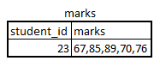image.png 2.35 KB
﻿This can be interpreted as﻿
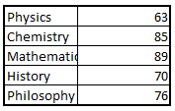image.png 3.75 KB

Note : The Physics marks in 2nd table should be 67 instead of 63.

﻿Write a query to determine the id of the student who has the highest average in Physics, Chemistry and Mathematics. Assume that the marks are all stored as two digit numbers.

use upgrad;

# Write your code below
CREATE TEMPORARY TABLE saf_avg(
student_id INT PRIMARY KEY,
avg_marks DEC(10,2)
);

insert into saf_avg (student_id, avg_marks)
SELECT student_id,
(cast(SUBSTRING_INDEX(marks, ',', 1) as signed) +
cast(SUBSTRING_INDEX(SUBSTRING_INDEX(marks, ',', 2), ',',-1) as signed) +
cast(SUBSTRING_INDEX(SUBSTRING_INDEX(marks, ',', 3), ',',-1) as signed ))/3
as mark_avg
FROM marks order by mark_avg desc limit 1;
SELECT student_id from saf_avg limit 1;

use upgrad;

select student_id
from marks
order by substring(marks, 1, 2) + substring(marks, 4, 2) + substring(marks, 7, 2) desc
limit 1;

